Barcode Reader Specification

SICK - CLV632-0120



Customer: Vistaprint Winterthur

Project: Line ALADDIN Paper Stream

Projectnr..: 10116.04.01

Version: 0.03

Storage: D:\daten\60_Projekte\10116 Vista Print\04 Line - ALADDIN\01 Development\20_Engineering\20_Development\Specification\Line-Aladdin Shirtstream PLC Spec V0.12.docx

# Table of contents

1 Table of contents 2

2 Introduction 3

2.1 Scope 3

2.2 Reference Documentation 3

2.3 Version 3

2.4 Abbreviations, definitions, glossary 3

3 Common information’s 4

3.1 Used software components and libraries 4

3.2 Used SOPAS commands 4

3.3 SOPAS response errors 4

3.4 Test environment 5

3.5 Sensor settings (Object trigger) 6

3.6 Using the terminal emulator 6

4 Controller Description 7

4.1 Level 0 Element: Barcode controller (Class BCC) 7

4.2 Driver Element: Barcode driver (Class BCD) 9

# Introduction

## Scope

This document gives an overview about the functions of controller BCC and BCD for controlling the SICK barcode reader and is solely for the benefit of Vistaprint and all the persons that are involved at platform development. These are software developers, quality engineers and maintenance engineers.

## Reference Documentation

|  |  |  |
| --- | --- | --- |
| Documents | Version | Datum |
| CLV62x-65x-Client-V510_ProgrammingGuide.pdf | V5.10 | 2011-08-19 |
| CLV63x_manual.pdf |  | 2008-04-16 |
| SICK Application Report - CLV6xx_Commands.doc |  | 2011-01-28 |
| Beckhoff InfoSys - [TF6310 TC3 TCP/IP](http://infosys.beckhoff.com/index.php?content=../content/1031/tf6310_tc3_tcpip/html/TcPlcLibSocketHelper_FB_ClientServerConnection.htm&id=) |  |  |
|  |  |  |
|  |  |  |
|  |  |  |
|  |  |  |

## Version

|  |  |  |  |  |
| --- | --- | --- | --- | --- |
| Description | Author | State | Version | Date |
| Start | AVME/DSC | d | 0.1 | 2014-01-09 |
| Changes on .cur interface of BCC. Add new chapter with SOPAS response error | AVME/DSC | d | 0.2 | 2014-01-27 |
| Updated Document regarding RP-208 Implement sensor signal input for triggering a barcode scan | AVME/DSC | d | 0.3 | 2014-07-15 |
|  |  |  |  |  |
|  |  |  |  |  |
|  |  |  |  |  |
|  |  |  |  |  |
|  |  |  |  |  |
|  |  |  |  |  |

State: **d** = design, **r** = released

## Abbreviations, definitions, glossary

|  |  |
| --- | --- |
| Designation | Name |
| SOPAS | Software engineering tool for configuration of SICK components |
|  |  |
|  |  |
|  |  |
|  |  |
|  |  |
|  |  |
|  |  |

# Common information’s

## Used software components and libraries

|  |  |  |
| --- | --- | --- |
| Description | Version | Datum |
| SOPAS engineering tool | V2.38.0 Build 5712 |  |
| Beckhoff TCP/IP server (TF6310-TCP-IP) | V1.0.66.0 | 2013-08-07 |
| TwinCAT TCP/IP connection server library (Tc2_TcpIp) | V3.3.1.0 |  |
|  |  |  |
|  |  |  |

## Used SOPAS commands

|  |  |
| --- | --- |
| Command | Description |
| sRI0 | Communication test. |
| sMN mTCgateon | Command to trigger the scanner. (Type of SOPAS method) |
|  |  |
|  |  |
|  |  |

## SOPAS response errors

If an error occurs the Sopas command is answered with: [STX]sFA <x>[ETX] (as an error response)

Error list: <x> can have following values:

1: Access denied

2: Unknown Index

3: Unknown Index

4: Wrong Condition

5: Invalid Data

6: Unknown Error

7: Too Many Parameter

8: Parameter Missing

9: Wrong Parameter

A: No Write Access

B: Unknown Command

C: Unknown Command

D: Server Busy

E: Textstring Too Long

F: Unknown Event

10: Too many Parameter

11: Invalid Character

12. No Message

13: No Answer

14: Internal Error

15: HubAddress: wrong

16: HubAddress: error

17: HubAddress: error

The error value is an additional information of BCC alarm “**Error response from sensor**”

## Test environment



## Sensor settings (Object trigger)

The following settings are necessary that the sensor can listen to SOPAS commands send over TCP/IP.

Start/Stop over command. Duration specifies the sampling. (Time in that the sensor waits for a barcode)

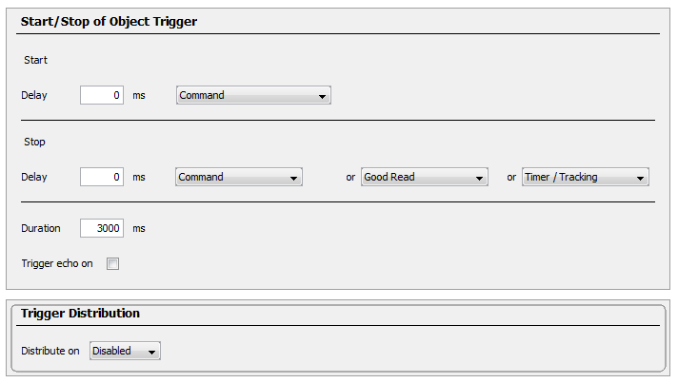

## Using the terminal emulator

For sending commands to the device, the SOPAS integrated terminal emulator can be used.

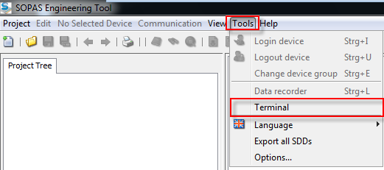

The following example shows how the trigger can be started to read a barcode by sending command

*sMN mTCgateon*.

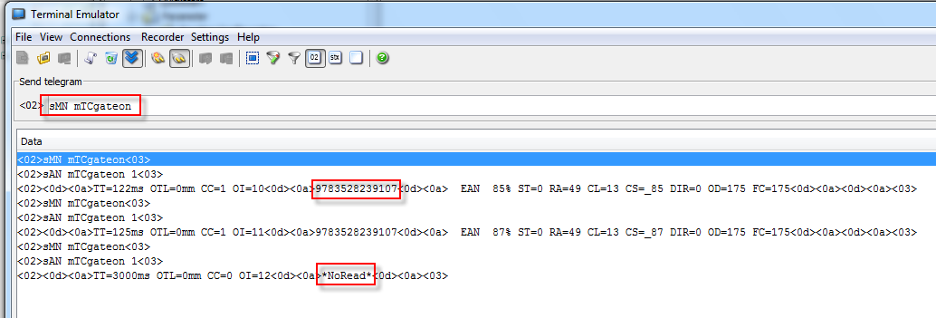

# Controller Description

## Level 0 Element: Barcode controller (Class BCC)

**Functionality**

The barcode controller handle the communication to the barcode reader driver.

**Main Sequence**

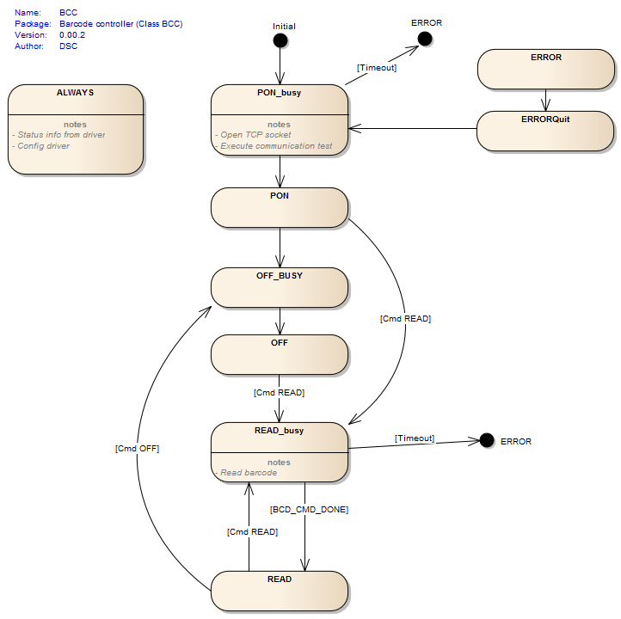

**Commands**

* PON (Open the TCP socket and execute a communication test)
* OFF (No Action Done)
* READ (Read barcode. Command switch on the sensor gate for X-time)

**Configuration**

|  |  |  |
| --- | --- | --- |
| *Variable* | *Datatype* | *Description* |
| strSensorIPAdr | STRING(15) | IP Adress of the sensor (PLC is the client) |
| udiSensorPort | UDINT | Port number of the sensor |

**Parameter**

|  |  |  |
| --- | --- | --- |
| *Variable* | *Datatype* | *Description* |
| udiTOPowerOn_ms | UDINT | [ms] Timeout power on |
| udiTORead_ms | UDINT | [ms] Timeout read |
| udiExecuteScanDelayTime_ms | UDINT | [ms] Barcode scan delay time - Delay before a barcode scan will be triggered after a new product has been detected by trigger sensor input |

**Current Values**

|  |  |  |
| --- | --- | --- |
| *Variable* | *Datatype* | *Description* |
| bolConnected | BOOL | Sensor connected |
| bolComChecked | BOOL | Communication checked during PON |
| bolNewCodeReaded | BOOL | 1 = new bar code readed |
| bolNoRead | BOOL | 1 = no code readed, answer *No Read* |
| stData | T_BCC_Data | Sensor data |

**Device data T_BCC_Data**

|  |  |  |
| --- | --- | --- |
| *Variable* | *Datatype* | *Description* |
| uliBarCode | ULINT | The read barcode |
| strBarCode | STRING | The read barcode. If no barcode has been read ‘NoRead’ |

**Errors**

* Barcode reader driver error category: INFO
* Initialisation error from barcode reader. No answer from device. category: OFF
* Barcode could not be read. Answer *NoRead* from device category: INFO
* Timeout wait on data category: INFO
* Error response from sensor category: INFO
* New scan was triggered during a scan was already in progress category: WARNING

**IO**

* In_bolSensorTrigScan (Sensor input for triggering a new barcode scan)

## Driver Element: Barcode driver (Class BCD)

**Functionality**

TCP-IP driver for SICK barcode reader Type “CLV632-0120”. This driver work as a TCP client.

**Main Sequence**

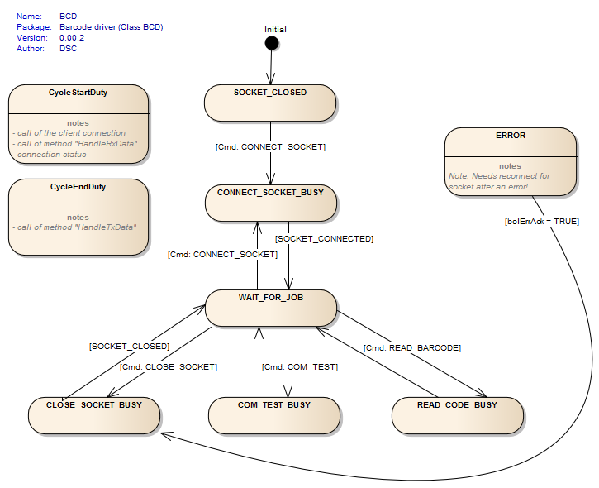

**Data Handling**

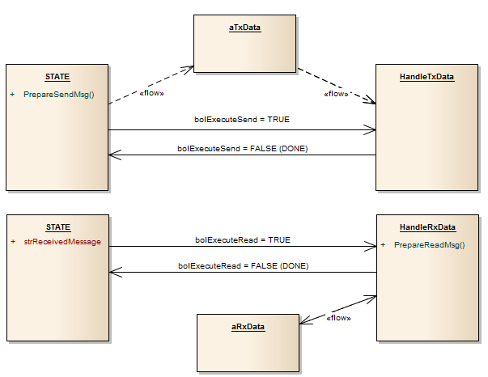

**Commands**

* CONNECT_SOCKET (Connect TCP socket)
* CLOSE_SOCKET (Close TCP socket)
* COM_TEST (Execute a communication test. Sending CMD and check answer)
* READ_BARCODE (Read barcode and prepare data)
* READ_DEV_INFO (not yet integrated)
* READ_OP_DATA (not yet integrated)
* READ_SERVICE_INFO (not yet integrated)

**Configuration**

|  |  |  |
| --- | --- | --- |
| *Variable* | *Datatype* | *Description* |
| bolSimulation | BOOL | Not used |
| strSensorIPAdr | STRING(15) | IP Adress of the sensor (PLC is the client) |
| udiSensorPort | UDINT | Port number of the sensor |
|  |  |  |

**Parameter**

|  |  |  |
| --- | --- | --- |
| *Variable* | *Datatype* | *Description* |
| tTOConnection | TIME | Default TO for FB_ClientServerConnection |
| tTOSend | TIME | Default TO for FB_SocketSend |
| tTOReceive | TIME | Default TO for FB_SocketReceive |
|  |  |  |

**Device data T_BCC_Data**

|  |  |  |
| --- | --- | --- |
| *Variable* | *Datatype* | *Description* |
| bolCodeReaded | BOOL |  |
| uliBarCode | ULINT | The read barcode |
| strBarCode | STRING | The read barcode. If no barcode has been read ‘NoRead’ |
| stDevInfo | T_BCD_DeviceInfo | Device Information |
| stServInfo | T_BCD_ServiceInfo | not currently used |
| stOpData | T_BCD_OperatingData | not currently used |
|  |  |  |

**T_BCD_DeviceInfo**

|  |  |  |
| --- | --- | --- |
| *Variable* | *Datatype* | *Description* |
| strComTestResult | STRING(40) | Contains results after communication test |
| strManufacturer | STRING(25) | not currently used |
| strDeviceType | STRING(25) | not currently used |
| strOrderNumber | STRING(20) | not currently used |
| strSWVersion | STRING(10) | not currently used |
| strFWVersion | STRING(10) | not currently used |
| strSerialNumber | STRING(20) | not currently used |

**T_BCD_OperatingData**

|  |  |  |
| --- | --- | --- |
| *Variable* | *Datatype* | *Description* |
| strPowerOnCounter | STRING(25) | not currently used |
| strOpHours | STRING(25) | not currently used |
| strPowerOnHours | STRING(20) | not currently used |
|  |  |  |
|  |  |  |
|  |  |  |
|  |  |  |

**T_BCD_ServiceInfo**

|  |  |  |
| --- | --- | --- |
| *Variable* | *Datatype* | *Description* |
| strLastUsername | STRING(25) | not currently used |
| strLastParChangeDate | STRING(10) | not currently used |
| strLastParChangeTime | STRING(5) | not currently used |
|  |  |  |
|  |  |  |
|  |  |  |
|  |  |  |